Problem 1

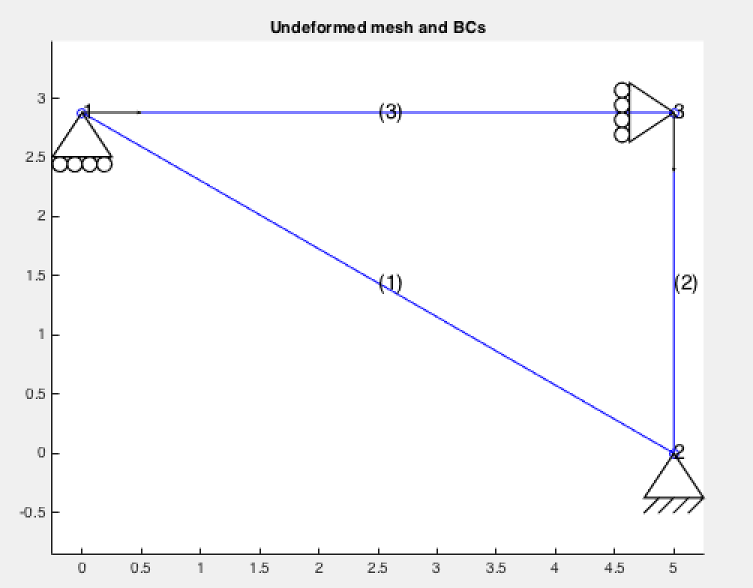

Figure 1 Input geometry

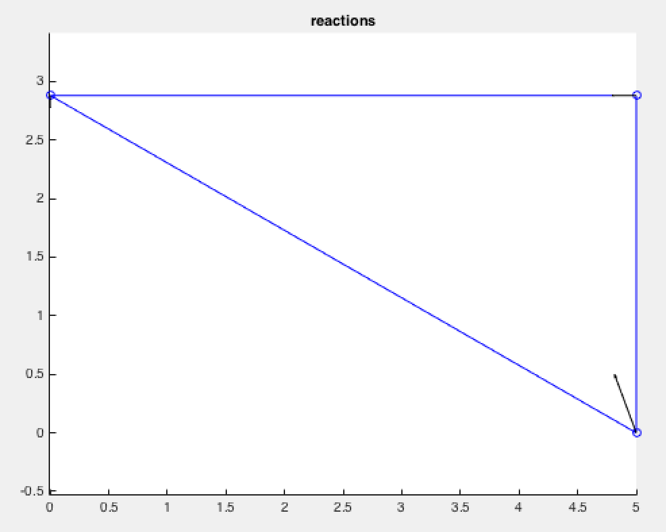

Figure 2 Reactions

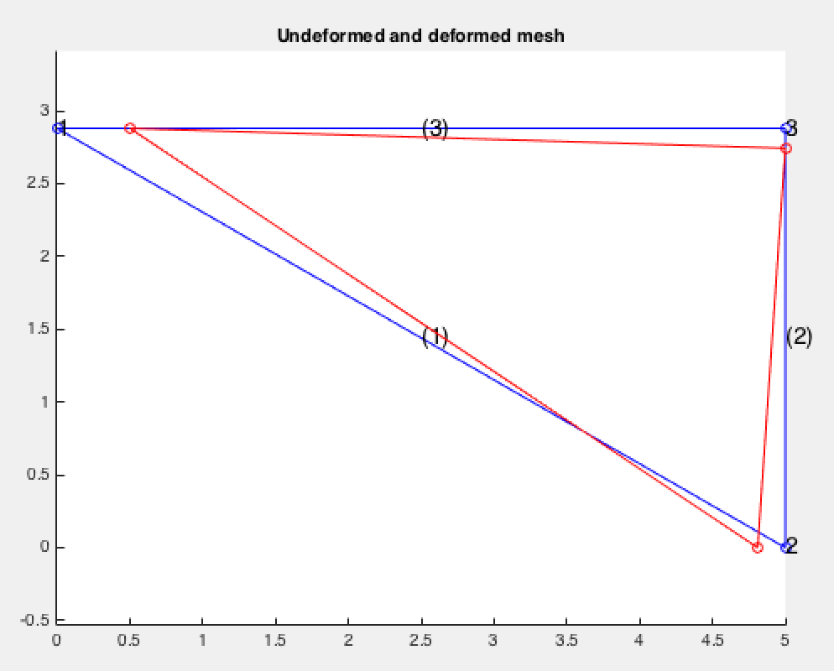

Figure 3 Undeformed/Deformed Shape

Nodal Displacements:

MATLAB Results

|  |  |  |
| --- | --- | --- |
| Node | Displacement 1 (m) | Displacement 2 (m) |
| 1 | 0.00263 | 0 |
| 2 | -0.001 | 0 |
| 3 | 0 | -0.00072 |

Hand-calculated Results:

|  |  |  |
| --- | --- | --- |
| Node | Displacement 1 (m) | Displacement 2 (m) |
| 1 | 0.00261 | 0 |
| 2 | -0.001 | 0 |
| 3 | 0 | -0.0007 |

Nodal Reactions:

MATLAB Results

|  |  |  |
| --- | --- | --- |
| Node | Reaction 1 (N) | Reaction 2 (N) |
| 1 | 0 | -27245.8 |
| 2 | -47301.7 | 127246 |
| 3 | -52698.3 | 0 |

Hand-calculated Results:

|  |  |  |
| --- | --- | --- |
| Node | Reaction 1 (N) | Reaction 2 (N) |
| 1 | 0 | -27100.0 |
| 2 | -46900.0 | 123700 |
| 3 | -52200.0 | 0 |

Element Axial force/stress/strain

MATLAB Results

|  |  |
| --- | --- |
| Element | Axial Force (N) |
| 1 | -54587.4 |
| 2 | -100000 |
| 3 | -52698.3 |

Hand-calculated Results:

|  |  |
| --- | --- |
| Element | Axial Force (N) |
| 1 | -54200.0 |
| 2 | -96600.0 |
| 3 | -52200.0 |

Discuss: All units as shown. Small deviations that occurred due to rounding.

CODE:

Only parts of the code that were changed only refer to the change of element and node number and the connectivity between the nodes. Additionaly, the material assignments required changes in material properties

%%%%%%%%%%%%%%%%%%%%%%%%%%%%%%%%%%%%%%%%%%%%%%%%%%%%%%%%%%%%

% DATA %

%%%%%%%%%%%%%%%%%%%%%%%%%%%%%%%%%%%%%%%%%%%%%%%%%%%%%%%%%%%%

nmat=2;

%%%%%%%%%%%%

% Material %

%%%%%%%%%%%%

E(1)=2.e11; % Young's modulus

E(2)=2.e11; % Young's modulus

%%%%%%%%%%%%%

% Geometric %

%%%%%%%%%%%%%

A(1)=0.002; % Area

A(2)=0.0005; % Area

%%%%%%%%

% Mesh %

%%%%%%%%

nsd=2; % number of space dimension

ndf=nsd; % number of freedom per node

nen=2; % number of element nodes

nel=3; % number of elements/trusses

nnp=3; % number of nodal points

%%%%%%%%%%%%%%%%%%%%%

% Nodal coordinates %

%%%%%%%%%%%%%%%%%%%%%

% xn(i,N):= coordinate i for node N

% N=1,...,nnp

% i=1,...,nsd

xn=zeros(nsd,nnp);

xn(1,1)=0;

xn(2,1)=2.88;

xn(1,2)=5;

xn(2,2)=0;

xn(1,3)=5;

xn(2,3)=2.88;

%%%%%%%%%%%%%%%%

% Connectivity %

%%%%%%%%%%%%%%%%

% ien(a,e)=N

% N: global node number - N=1,...,nnp

% e: element number - e=1,...,nel

% a: local node number - a=1,...,nen

ien=zeros(nen,nel);

mat=zeros(nel);

ien(1,1)=1; ien(2,1)=2; mat(1)=2;

ien(1,2)=2; ien(2,2)=3; mat(2)=1;

ien(1,3)=3; ien(2,3)=1; mat(3)=2;

%%%%%%%%%%%%%%%%%%%%%%%

% Boundary conditions %

%%%%%%%%%%%%%%%%%%%%%%%

% prescribed displacement (essential boundary condition)

%

% idb(i,N)=1 if the degree of freedom i of the node N is prescribed

% =0 otherwise

%

% 1) initialize idb to 0

idb=zeros(ndf,nnp);

% 2) enter the flag for prescribed displacement boundary conditions

idb(2,1)=1;

idb(1,2)=1;

idb(2,2)=1;

idb(1,3)=1;

%%%%%%%%%%%%%%%%%%%%%%%%%%%%%%%%%%%%%%%%%%%%%%%%%%%%%

% prescribed nodal displacement boundary conditions %

%%%%%%%%%%%%%%%%%%%%%%%%%%%%%%%%%%%%%%%%%%%%%%%%%%%%%

% g(i,N): prescribed displacement for the dof i of node N

% initialize g

g=zeros(ndf,nnp);

% enter the values

g(1,2)=-0.001;

%%%%%%%%%%%%%%%%%%%%%%%%%%%

% prescribed nodal forces %

%%%%%%%%%%%%%%%%%%%%%%%%%%%

% f(i,N): prescribed force for the dof i of node N

% initialize f

f=zeros(ndf,nnp);

% enter the values

f(1,1)=100000.;

f(2,3)=-100000.;

Problem 2: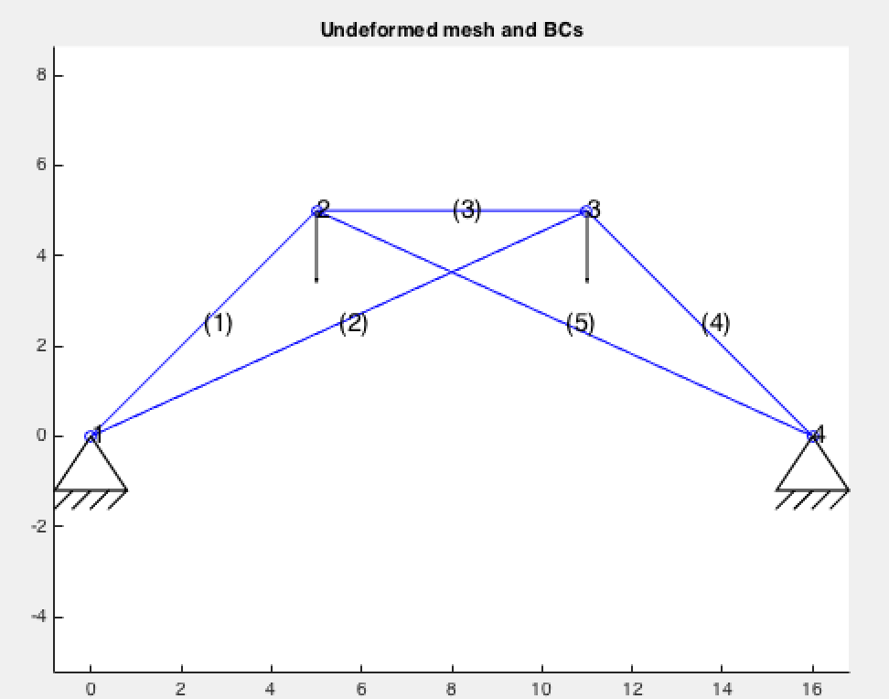

Figure 4 Input Geometry

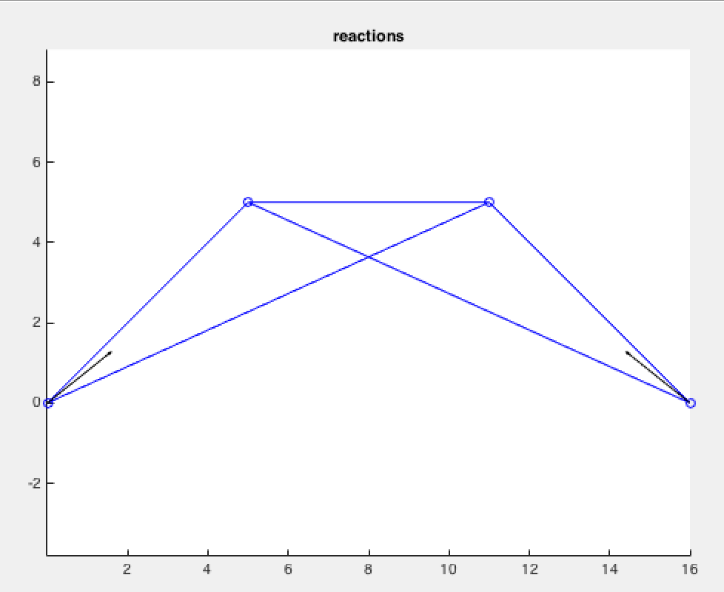

Figure 5 Reactions

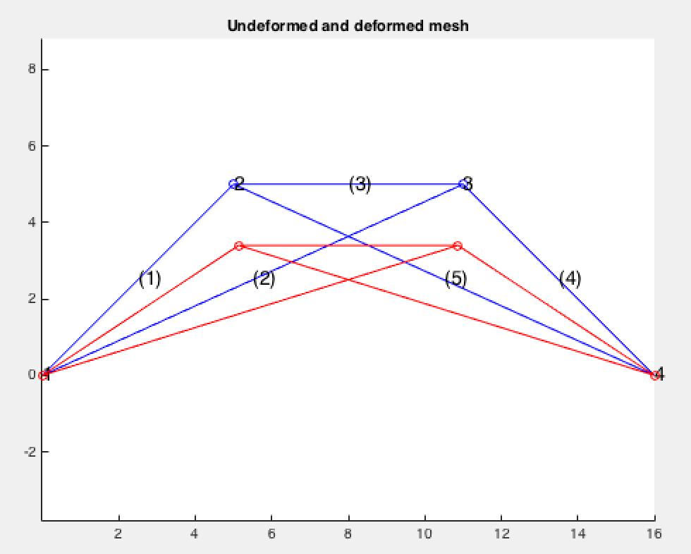

Figure 6 Undeformed/Deformed Shape

Nodal Displacements:

MATLAB Results

|  |  |  |
| --- | --- | --- |
| Node | Displacement 1 (m) | Displacement 2 (m) |
| 1 | 0 | 0 |
| 2 | 5.69657*10-5 | -0.000681035 |
| 3 | -5.69657*10-5 | -0.000681035 |
| 4 | 0 | 0 |

Hand-calculated Results:

|  |  |  |
| --- | --- | --- |
| Node | Displacement 1 (m) | Displacement 2 (m) |
| 1 | 0 | 0 |
| 2 | 5.67*10-5 | -0.000683 |
| 3 | -5.67*10-5 | -0.000683 |
| 4 | 0 | 0 |

Nodal Reactions:

MATLAB Results

|  |  |  |
| --- | --- | --- |
| Node | Reaction 1 (N) | Reaction 2 (N) |
| 1 | 12468.3 | 10000 |
| 2 | 0 | 0 |
| 3 | 0 | 0 |
| 4 | -12468.3 | 10000 |

Hand-calculated Results:

|  |  |  |
| --- | --- | --- |
| Node | Reaction 1 (N) | Reaction 2 (N) |
| 1 | 12540.0 | 10000 |
| 2 | 0 | 0 |
| 3 | 0 | 0 |
| 4 | -12540 | 10000 |

Element Axial force/stress/strain

MATLAB Results

|  |  |
| --- | --- |
| Element | Axial Force (N) |
| 1 | -11233.2 |
| 2 | -4970.71 |
| 3 | -3417.94 |
| 4 | -11233.2 |
| 5 | -4970.71 |

Hand-calculated Results:

|  |  |
| --- | --- |
| Element | Axial Force (N) |
| 1 | -11240.0 |
| 2 | -4960.0 |
| 3 | -3400.0 |
| 4 | -11240.0 |
| 5 | -4960.0 |

Discuss: All units as shown. Small deviations that occurred due to rounding.

CODE:

Only parts of the code that were changed only refer to the change of element and node number and the connectivity between the nodes.

%%%%%%%%%%%%%%%%%%%%%%%%%%%%%%%%%%%%%%%%%%%%%%%%%%%%%%%%%%%%

% DATA %

%%%%%%%%%%%%%%%%%%%%%%%%%%%%%%%%%%%%%%%%%%%%%%%%%%%%%%%%%%%%

%%%%%%%%%%%%

% Material %

%%%%%%%%%%%%

E=1.2e11; % Young's modulus

%%%%%%%%%%%%%

% Geometric %

%%%%%%%%%%%%%

A=0.0015; % Area

%%%%%%%%

% Mesh %

%%%%%%%%

nsd=2; % number of space dimensions

ndf=nsd; % number of freedom per node

nen=2; % number of element nodes

nel=5; % number of elements/trusses

nnp=4; % number of nodal points

%%%%%%%%%%%%%%%%%%%%%

% Nodal coordinates %

%%%%%%%%%%%%%%%%%%%%%

% xn(i,N):= coordinate i for node N

% N=1,...,nnp

% i=1,...,nsd

xn=zeros(nsd,nnp);

xn(1,1)=0;

xn(2,1)=0;

xn(1,2)=5;

xn(2,2)=5;

xn(1,3)=11;

xn(2,3)=5;

xn(1,4)=16;

xn(2,4)=0;

%%%%%%%%%%%%%%%%

% Connectivity %

%%%%%%%%%%%%%%%%

% ien(a,e)=N

% N: global node number - N=1,...,nnp

% e: element number - e=1,...,nel

% a: local node number - a=1,...,nen

ien=zeros(nen,nel);

ien(1,1)=1; ien(2,1)=2;

ien(1,2)=1; ien(2,2)=3;

ien(1,3)=2; ien(2,3)=3;

ien(1,4)=3; ien(2,4)=4;

ien(1,5)=2; ien(2,5)=4;

%%%%%%%%%%%%%%%%%%%%%%%

% Boundary conditions %

%%%%%%%%%%%%%%%%%%%%%%%

% prescribed displacement (essential boundary condition)

%

% idb(i,N)=1 if the degree of freedom i of the node N is prescribed

% =0 otherwise

%

% 1) initialize idb to 0

idb=zeros(ndf,nnp);

% 2) enter the flag for prescribed displacement boundary conditions

idb(1,1)=1;

idb(2,1)=1;

idb(1,4)=1;

idb(2,4)=1;

%%%%%%%%%%%%%%%%%%%%%%%%%%%%%%%%%%%%%%%%%%%%%%%%%%%%%

% prescribed nodal displacement boundary conditions %

%%%%%%%%%%%%%%%%%%%%%%%%%%%%%%%%%%%%%%%%%%%%%%%%%%%%%

% g(i,N): prescribed displacement for the dof i of node N

% initialize g

g=zeros(ndf,nnp);

% enter the values

%%%%%%%%%%%%%%%%%%%%%%%%%%%

% prescribed nodal forces %

%%%%%%%%%%%%%%%%%%%%%%%%%%%

% f(i,N): prescribed force for the dof i of node N

% initialize f

f=zeros(ndf,nnp);

% enter the values

f(2,2)=-10000.;

f(2,3)=-10000.;

Problem 3: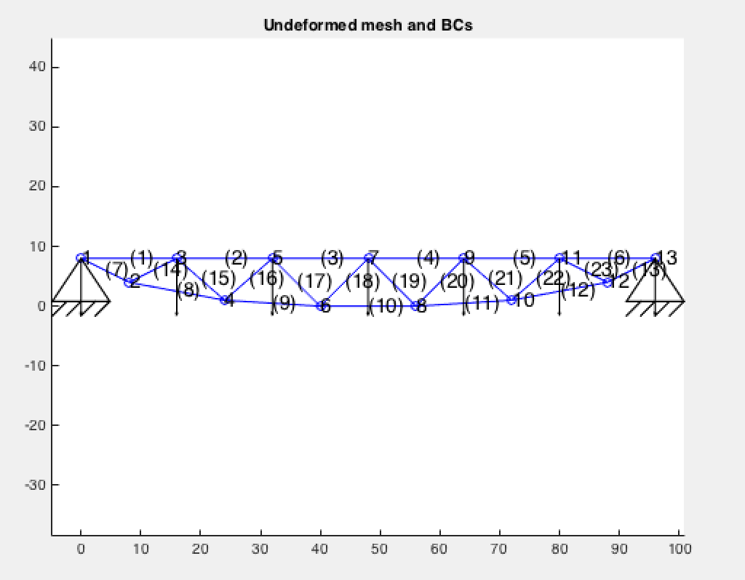

Figure 7 Input Geometry

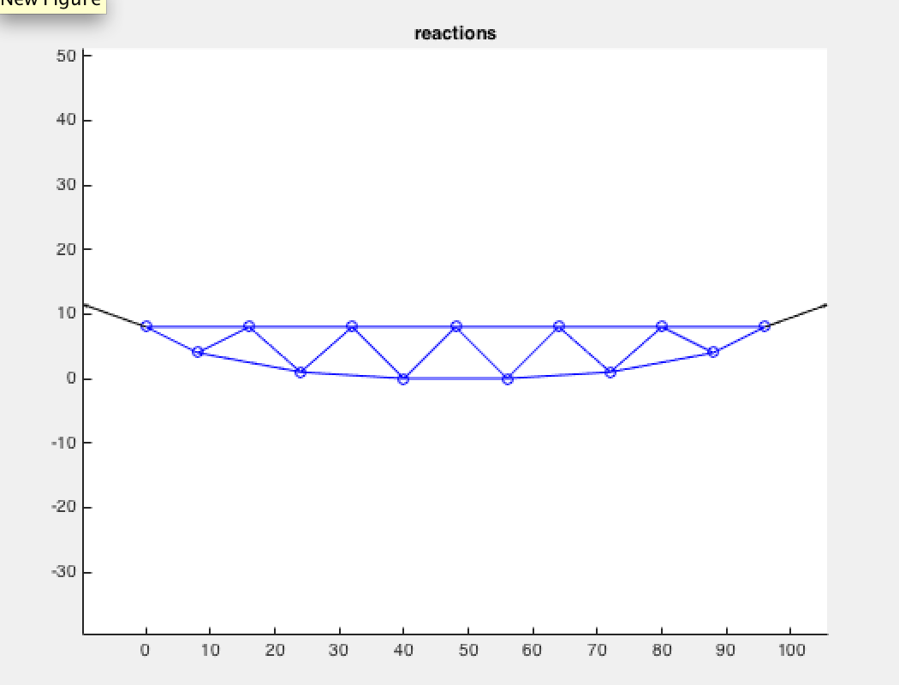

Figure 8 Reactions

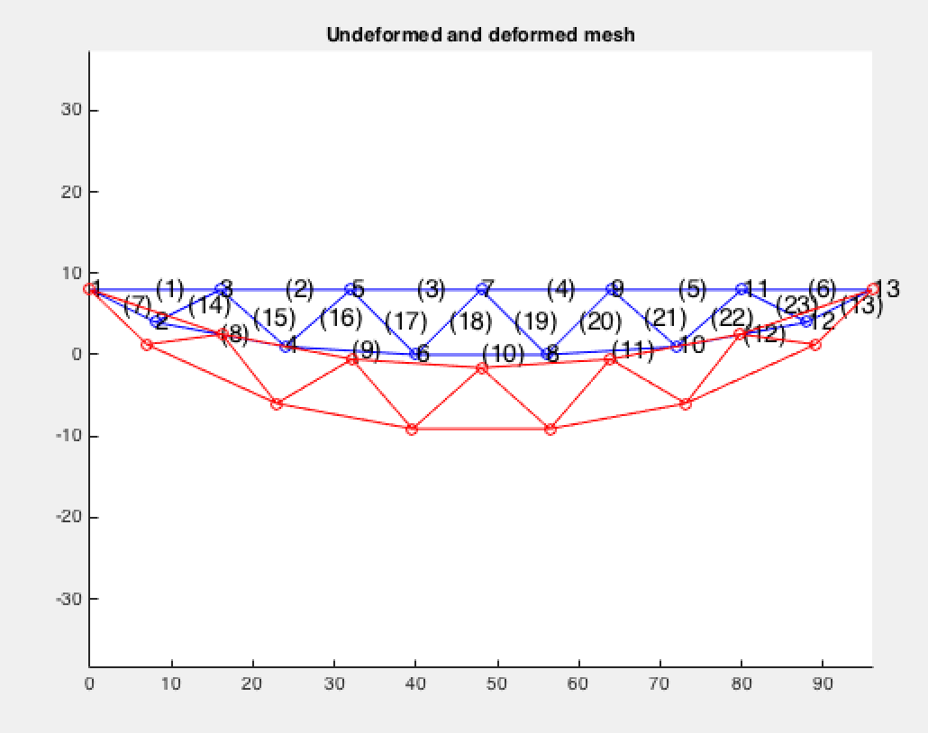

Figure 9 Deformed/Undeformed Shape

Nodal Reactions

|  |  |  |
| --- | --- | --- |
| Node | Reaction x (N) | Reaction y (N) |
| A | -69861.9 | 25000 |
| B | 69861.9 | 25000 |

Element Axial force/stress/strain

elem force stress strain

|  |  |  |
| --- | --- | --- |
| Element Number | MATLAB Result (N) | Calculated Result (N) |
| 1 | 19761 | 50000.0 |
| 2 | -4523.81 | 71200.0 |
| 3 | -15238.1 | 82100.0 |
| 4 | -15238.1 | 82100.0 |
| 5 | -4523.81 | 71200.0 |
| 6 | 19761.9 | 50000.0 |
| 7 | 55901.7 | 55900.0 |
| 8 | 73994.6 | 73900.0 |
| 9 | 85499.8 | 82100.0 |
| 10 | 90000 | 87100.0 |
| 11 | 85499.8 | 82100.0 |
| 12 | 73994.6 | 73900.0 |
| 13 | 55901.7 | 55900.0 |
| 14 | -25409. | -25300.0 |
| 15 | 2070.81 | 2070.0 |
| 16 | -14679.7 | -15000.0 |
| 17 | -471.405 | -170.0 |
| 18 | -7071.07 | -7100.0 |
| 19 | -7071.07 | -7100.0 |
| 20 | -471.405 | -170.0 |
| 21 | -14679.7 | 15000.0 |
| 22 | 2070.81 | 2070.0 |
| 23 | -25409.9 | -25300.0 |

Discuss: The deviations above happened due to a horizontal reaction force coming from the two pins, as seen in the charts and diagram above. This is the reason why the horizontal forces were miscalculated in the MATLAB program. The MATLAB program, despite correct code-correction seems to let the pins absorb the load that is applied on them, returning only 25kN of force each as a reaction, instead of the expected 35kN. It is suspected the the reaction calculation metric causes this error.

Cause of deviation for blue errors above is unknown (potential hand calculation error? Or the causes that make the values for the horizontal bars deviate also cause the two values above to behave the same way?)

Solutions attempted were the following:

-Adding an extra node at an infinitesimal length to the right and left of nodes A and B (or 1 and 13) respectively, yielding a singular matrix error and NaN values returned.

-Applying twice the load on the pins, yielding the same 25kN reaction for each pin.

CODE:

Only parts of the code that were changed only refer to the change of element and node number and the connectivity between the nodes.

%%%%%%%%%%%%%%%%%%%%%%%%%%%%%%%%%%%%%%%%%%%%%%%%%%%%%%%%%%%%

% DATA %

%%%%%%%%%%%%%%%%%%%%%%%%%%%%%%%%%%%%%%%%%%%%%%%%%%%%%%%%%%%%

%%%%%%%%%%%%

% Material %

%%%%%%%%%%%%

E=2e11; % Young's modulus

%%%%%%%%%%%%%

% Geometric %

%%%%%%%%%%%%%

A=0.0012; % Area

%%%%%%%%

% Mesh %

%%%%%%%%

nsd=2; % number of space dimensions

ndf=nsd; % number of freedom per node

nen=2; % number of element nodes

nel=23; % number of elements/trusses

nnp=13; % number of nodal points

%%%%%%%%%%%%%%%%%%%%%

% Nodal coordinates %

%%%%%%%%%%%%%%%%%%%%%

% xn(i,N):= coordinate i for node N

% N=1,...,nnp

% i=1,...,nsd

xn=zeros(nsd,nnp);

xn(1,1)=0;

xn(2,1)=8;

xn(1,2)=8;

xn(2,2)=4;

xn(1,3)=16;

xn(2,3)=8;

xn(1,4)=24;

xn(2,4)=1;

xn(1,5)=32;

xn(2,5)=8;

xn(1,6)=40;

xn(2,6)=0;

xn(1,7)=48;

xn(2,7)=8;

xn(1,8)=56;

xn(2,8)=0;

xn(1,9)=64;

xn(2,9)=8;

xn(1,10)=72;

xn(2,10)=1;

xn(1,11)=80;

xn(2,11)=8;

xn(1,12)=88;

xn(2,12)=4;

xn(1,13)=96;

xn(2,13)=8;

xn(1,14)=0;

xn(2,14)=8;

xn(1,15)=96;

xn(2,15)=8;

%%%%%%%%%%%%%%%%

% Connectivity %

%%%%%%%%%%%%%%%%

% ien(a,e)=N

% N: global node number - N=1,...,nnp

% e: element number - e=1,...,nel

% a: local node number - a=1,...,nen

ien=zeros(nen,nel);

ien(1,1)=1; ien(2,1)=3;

ien(1,2)=3; ien(2,2)=5;

ien(1,3)=5; ien(2,3)=7;

ien(1,4)=7; ien(2,4)=9;

ien(1,5)=9; ien(2,5)=11;

ien(1,6)=11; ien(2,6)=13;

ien(1,7)=1; ien(2,7)=2;

ien(1,8)=2; ien(2,8)=4;

ien(1,9)=4; ien(2,9)=6;

ien(1,10)=6; ien(2,10)=8;

ien(1,11)=8; ien(2,11)=10;

ien(1,12)=10; ien(2,12)=12;

ien(1,13)=12; ien(2,13)=13;

ien(1,14)=2; ien(2,14)=3;

ien(1,15)=3; ien(2,15)=4;

ien(1,16)=4; ien(2,16)=5;

ien(1,17)=5; ien(2,17)=6;

ien(1,18)=6; ien(2,18)=7;

ien(1,19)=7; ien(2,19)=8;

ien(1,20)=8; ien(2,20)=9;

ien(1,21)=9; ien(2,21)=10;

ien(1,22)=10; ien(2,22)=11;

ien(1,23)=11; ien(2,23)=12;

%%%%%%%%%%%%%%%%%%%%%%%

% Boundary conditions %

%%%%%%%%%%%%%%%%%%%%%%%

% prescribed displacement (essential boundary condition)

%

% idb(i,N)=1 if the degree of freedom i of the node N is prescribed

% =0 otherwise

%

% 1) initialize idb to 0

idb=zeros(ndf,nnp);

% 2) enter the flag for prescribed displacement boundary conditions

idb(1,1)=1;

idb(2,1)=1;

idb(1,13)=1;

idb(2,13)=1;

%%%%%%%%%%%%%%%%%%%%%%%%%%%%%%%%%%%%%%%%%%%%%%%%%%%%%

% prescribed nodal displacement boundary conditions %

%%%%%%%%%%%%%%%%%%%%%%%%%%%%%%%%%%%%%%%%%%%%%%%%%%%%%

% g(i,N): prescribed displacement for the dof i of node N

% initialize g

g=zeros(ndf,nnp);

% enter the values

%%%%%%%%%%%%%%%%%%%%%%%%%%%

% prescribed nodal forces %

%%%%%%%%%%%%%%%%%%%%%%%%%%%

% f(i,N): prescribed force for the dof i of node N

% initialize f

f=zeros(ndf,nnp);

% enter the values

f(2,1)=-10000.;

f(2,3)=-10000.;

f(2,5)=-10000.;

f(2,7)=-10000.;

f(2,9)=-10000.;

f(2,11)=-10000.;

f(2,13)=-10000.;

I pledge my Honor I have not violated the Honor Code during this examination.